Introduction
Single Page Application
Traditional page applications are pages that change all html once you route to one page on another.
If we inspect the HTML of a single page application we can notice that is really minimal with some <link> and some non standard tags.
The application’s content is created by javascript on client side, the content is fetched by the back-end and managed from the angular framework.
Advantages:
The transition is istantaneous, we remain in the same page but the content changes are controlled by javascript.
The backend usually is much simpler to build, the page is served statically, the front-end usually do calls REST api, we don’t need some server side tecnology like PHP
Downsides:
Some search engines cannot find some information, Google has non problem with it but some minor search engines like Bing could have some issues.
Angular Router
The main module for routing is the AppRoutingModule
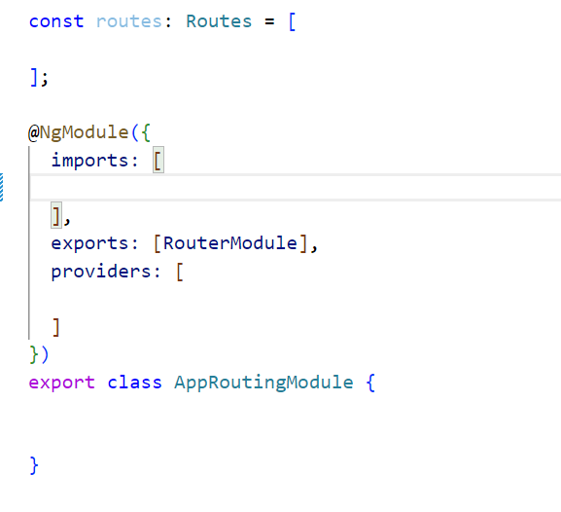
In the import section we have to call RouterModule.forRoot() function passing our routes:
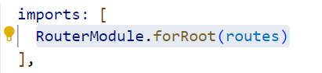
Then we can proceed configurating our routes:
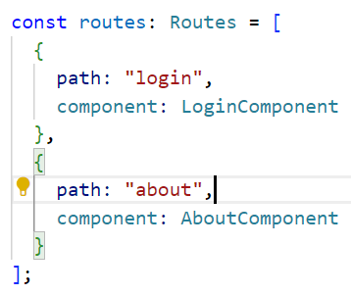
the basic route is an object containing the path and the component associated.
We indicate where the outlet should be positioned using:
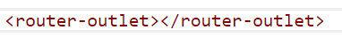
Angular RouterLink and routerLinkActive Directives
To give to angular the route we want to display we use the routerLink directive specificating the path like above:
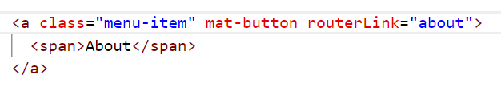
Or
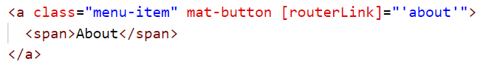
With the routerLinkActive directive we can pass a css class whenever the route is active for example:
When “about” route is displayed the link will have the menu-item-active css class.
In the previous examples we used relative paths, but it’s recommended to use absolute paths:
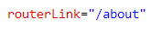
Angular Router Essentials
Lazy Loading setup
When a route is lazy loaded the component and all its directive and services are builded in a different javascript bundle and its loaded only when the route is active, if the user won’t navigate to that route the bundle will never be loaded.
This is a good practice to low the loading time of our application.
For example any path in the applicaton who start with “/courses” will need to trigger the lazy loading of the courses module, it is an asyncronous operation.
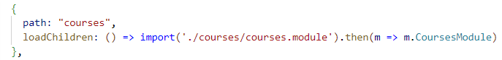
Instead of using component property we specify the loadChildren property.
So the end result is a function that, when called, returns a promise that when successfully evaluated, gives back to the angular router, a reference to the courses module.
Lazy Loaded Modules
For the Courses module we have to define its own routing configuration like we did for the app.module.
We first define the root path that in our application will be configured with “/courses”:
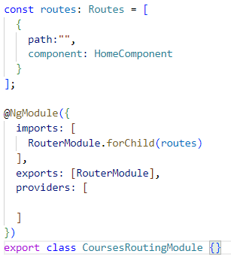
Notice that we use the angular RoutingModule.forChild() function and not RoutingModule.forRoot() because this module is a child module.
Now we have access to the route:
Angular Router Configuration: Best Practices
Page not found route:
We should add a page not found route to do so we define a route matching all the possible path, like an “all other path”.
It is important that the wildcard route “**” its at the end of the Routes array. Angular when matches a route won’t scan the next array element, so if the user path won’t match any of our routes will finish at the end of Routes array find the wildcard route.
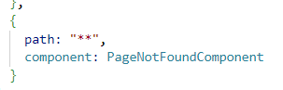
Root path:
We now want to redirect the root path to our courses path so when we tipe the base url we will be redirect to “/courses”.
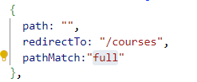
We need to set the pathMatch property to full because the empty string path corresponds to every path that starts with an empty string so basically everyone.
With pathMatch: full we specify a path that is equal to an empty string, without anything behind.
Router Path variables
Imagine that in our application we could click in a view course button that display the course detail.
We have defined the CoursesRoutingModule so in that module we reference the url path with “/courses”.
First we define the path in the CoursesRoutingModule with a pathVariable usting “:”:
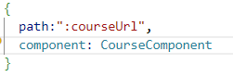(1)
We can acces dinamically tho the detail route using the routerLink directive:
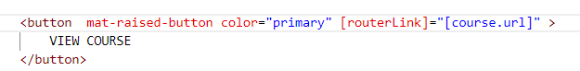
If course.url is mycourse1 the final url will be /courses/mycourse1.
But we need to get access to the path variable to know in the course component which course I’m navigating to, we will need the Router Resolver Service.
Router Resolver Services: Linkable page in a SPA
We could use a simple http service to load the course detail but we could have many issues and errors, the best way is to use a resolver service.
It’s a service implementing the Resolve interface, this interface takes one generic parameter that is the type of object fetching from the backend.
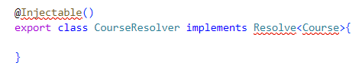
The only method we need to implement is the resolve method.
The activated route snapshot is a router object containing the information about which route is active.
In this case, the courses route.
We have also here the router state snapshot containing information about all the current state of the router.
We can see that we have to return as the output of a resolve, either an observable that emits as value a course, we can also return a promise and we can even return a course instance.
To return the observable we need the http service we already implemented, we will use the method:
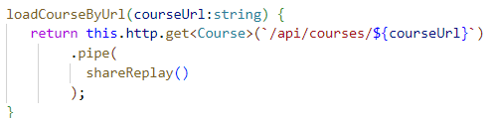
That need the specific url of the course.

After injecting our CoursesService we could access that method:
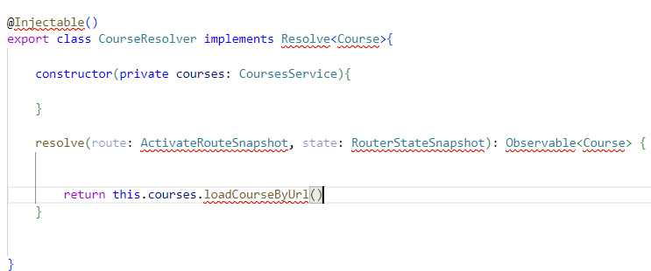
Now to access the courseUrl we use the ActivatedRouteSnapshot paramMap that contains all the path variables we have defined in our case we only have courseUrl (1).
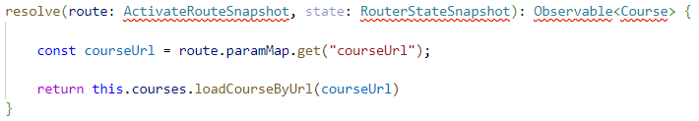
Now we need to import our CourseResolver as a provider and then call it in our route:
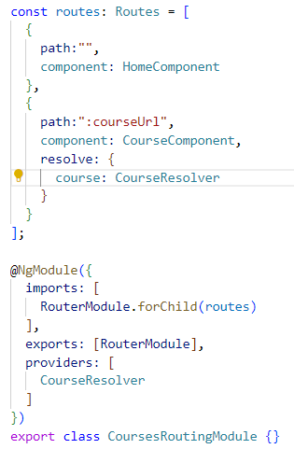
This will tell angular that before displaying the CourseComponent we need to fetch the course by the CourseResolver.
Now in our component we can use a special injectable ActivatedRoute service and get the course variable provided by the resolver.
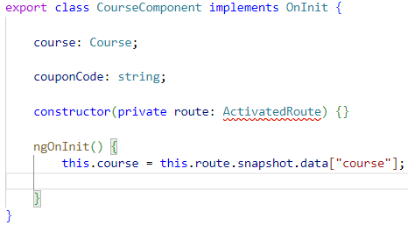
Angular Router Loading Indicator
While the routing transition is ongoing we want to display a loading indicator showing that something is loading from the backend or a lazy loaded module is getting fetched from the backend.
For now our LoadingComponent look like this:
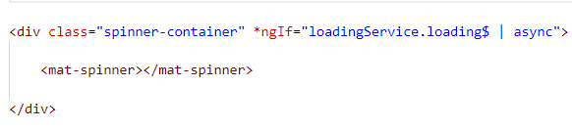
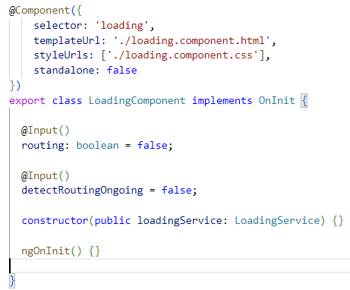
First of all we inject the angular Router api and we can now detect some events:
The loading service is a service that display or hide our loader.
We can implement our code in the ngOnInit method:
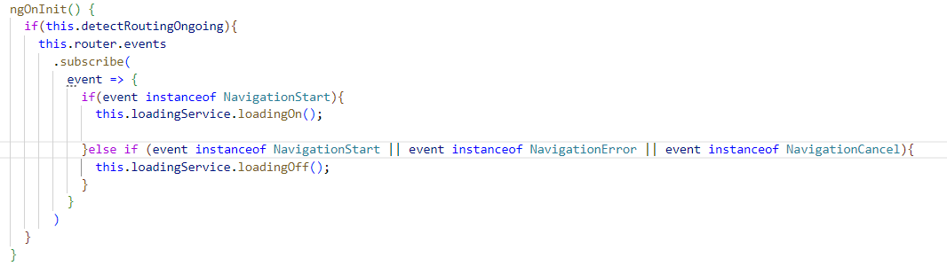
So the router.events return an observable that when resolve could fire some objects, analizing the instance of the fired object we know when to show or hide our loader.
If we want to show the loader when the lazy loaded module is getting fetched from the backend we can simply add RouteConfigLoadStart and RouteConfigLoadEnd:
And

Angular Router Master Detail with
Detail to Detail Navigation
Angular Router Child Routes
We already have implemented our lazy loaded module, we want now implement a new router outlet for this module so when we navigate in the /:courseUrl path we can configure some child route for the CourseComponent.
So for now our route look like this:
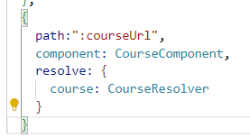
And we could imagine, for example, a default route to be displayed, which would contain a lessons list containing all the lessons of the course.
And then whenever we click in one of the lessons, we could display a different child route, which would be a lesson detail component showing the lesson that we have just clicked.
We can configure the children routes like this:
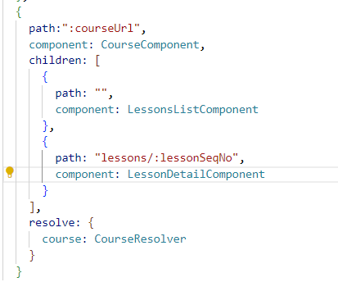
Notice that those are not lazy loaded.
Lets analize an example of a path:
This path will lazy loads the CoursesModule because it starts with “/courses”, then will load the CourseComponent because the url is pointing to the path variable :courseUrl.
All will be displayed in the main router-outlet of the application.
Now we define a new child router-outlet inside the CourseComponent.
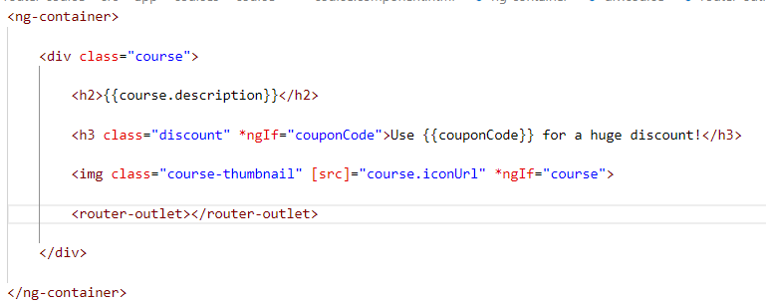
If we don’t add anything on the path this will match the empty path and the LessonsListComponent will be displayed.
If we add to the path “lessons/:lessonSeqNo”:
The LessonDetailComponent will be displayed instead of the LessonsListComponent.
Notice that the routerlink for the path “/lessons:lessonSeqNo” is:
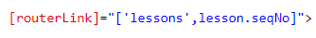
Programmatic RouterNavigation with the Router Service
Now imagine that we are in the LessonDetailComponent with path:
If we want to go back to the parent path:
(1)
We have to go back two time (like navigating with folders) our routerLink will be:
If we want to navigate via typescript method we should use the angular Router api, for example if we wanto to navigate from lesson 17 to lesson 16:
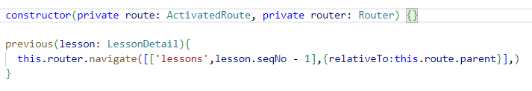
The configuration relativeTo specify that the path is relative to the parent path (1).

Understanding Route Snapshot vs Route Observables.
If we use this approach we could notice that the component is not updating because we are navigating in the same route so angular reuse the same instance of the component without destroying it.
So, instead of taking the lesson from the root snapshot, we need to take this from somewhere else in the activated route.
We have access to an observable from the ActivatedRoute:
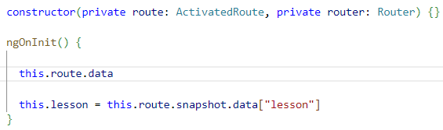
So the data observable is going to emit all the data produced by the resolvers associated to the current route.
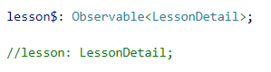
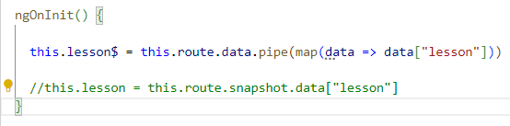
Now the variable lesson$ became an Observable so we have to treat it with the async pipe in the template:
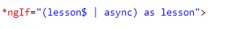
Why is this working correctly and why does the snapshot not work As expected?
As we can see, whenever we navigate, we are using the router service in order to trigger a router navigation.
And this affects the URL, and it also triggers the data resolver.
The resolver is correctly fetching the data from the backend, but when we navigate from one detail to the other, we haven't created a new instance of the lesson detail component.
This is an optimization in order to avoid to unnecessarily create new components, it's the same component so we should be able to reuse it.

Angular Router Guards

For this section we will use a custom http service here below:
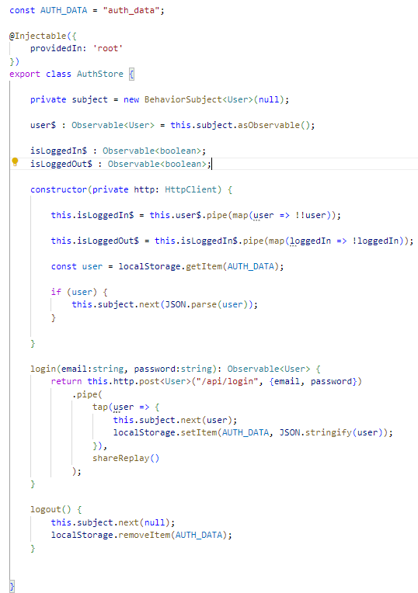
CanActivate Router Guards
A Router Guard is a special type of router angular service that gets invoked before a certain route transition takes place.
Using the service, we can determine, for example, if the routing transition is allowed or not.
If we want that only some users can have access to certain routes, we must use CanActivate Guards it will be invoked before the transition takes place.

We can start creating our guard:
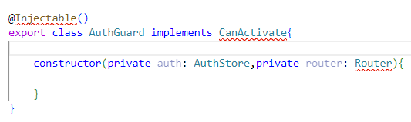
As we see it’s a simple service that implements the CanActivate interface, the contructor takes two argument, our custom http service and the angular Router service.
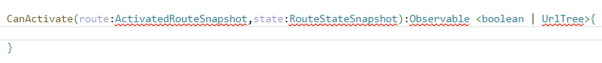
CanActivate observable is going to be returning true or false depending if the user can access the target screen of the route navigation or not.
Also, if the router guard wants to perform a redirect to another page such as, for example, in the case when the user is not authorized to see the target page.
In those cases, besides the boolean, the can activate method can also return a URL tree, which is a type that encapsulates the URL to which we want to redirect the user, in case that the user can't see the target route.
We will implement our method this way:
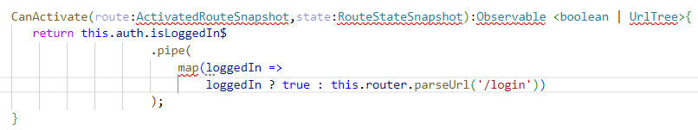
We are going to be applying here the Rxjs map operator and we are going to check here if the user is logged in or not.
So let's remember that the flag loggedIn is emitted by the isLoggedIn$ observable.
So if the user is logged in, then we want to emit (as the value of the resulting observable) the value true.
Otherwise we want to perform a redirection.
We can perform the redirection in the following way by returning here an UrlTree representing the URL of the login page. We can build conveniently such URL by calling here the router service and by calling the method parse URL to parse URL.
We are going to be passing the string form of the URL that we want to create, which is “/login”.
Now, in order to use it we have to declare it in our CoursesRoutingModule in the Providers array, than in our route whit the CanActivate property:
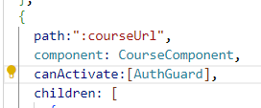
As we can see, for one same route we might have multiple CanActivate guards, so that's why we are passing here an array.
Notice that if we have multiple guards applied to the same component, we should implement them in a completely independent way, meaning that we should have no expectations that one guard is executed before the other.
CanActivateChild Router Guards
There’s a particular test that can be done:
Imagine that we are in the guard protected CourseComponent we log out,and for some reason we are not redirected to any other route.
If we try to get access to the child route with the lesson detail we could, and this is not the behaviour that we want.
We have to implement the CanActivateChild interface in our Guard:
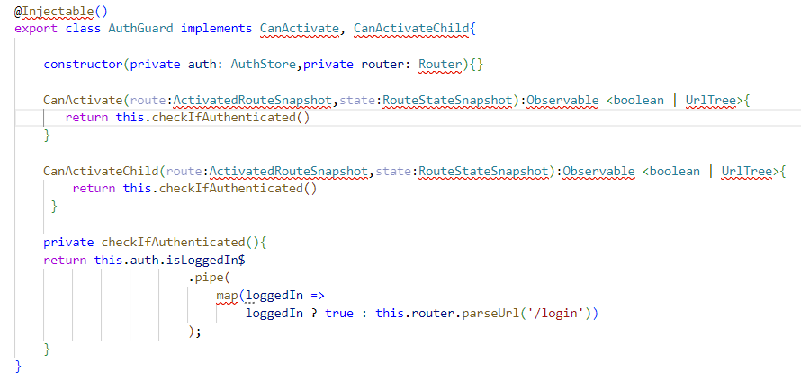
We moved the logic in a separate method.
Now we just have to specify the canActivateChild in our route: 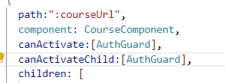
CanDeactivate Router Guards
A CanDeactivate Router Guard like the name indicates is going to get triggered when we want to navigate away from a component.
For example, when we want to navigate away from the course component, in that case, we might want to prevent that navigation if, for example, there is some unsafe data on the page or if there is, for example, a file upload operation still ongoing that we don't want to interrupt.
This time we want to ask to the user a confirmation when leaving the course component. To do so we implement a method in the CourseComponent:
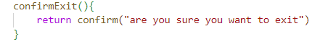
It will return a boolean.
The CanDeactivate interface took as argument the component we are leaving an the CanDeactivate method is really simple:
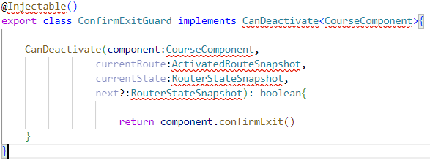
We just have ti import in our routing module as a provider an then specify the property canDeactivate:
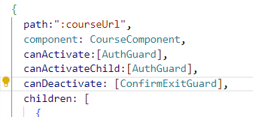
Notice that the canDeactivate Guard does not apply when navigating to the children routes.
CanLoad Router Guards
This particular guard Is for lazy loaded modules, the course component is protected from unauthenticated users by using the authentication guard.
However, if an authenticated user tries to access a path, for example, “/courses”, that unauthenticated user would still be able to download the code of the courses module from the server.
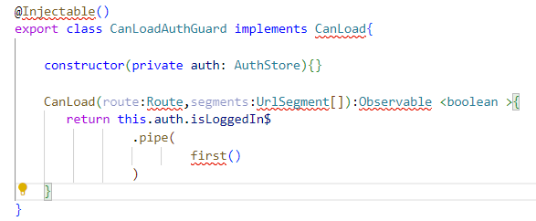
So this contains the current route that we are trying to access while loading a lazy loaded module then all the URL segments that we are currently trying to access.
For example, here we would have the “/courses” URL segment that corresponds here to the path to the lazy loaded module that we are trying to protect.
As the return of our method, we are going to be returning an observable of boolean.
If the user is an authenticated, the observable also needs to complete, otherwise the routing transition will not complete and the user will remain on the original screen before the routing navigation took place that’s why we use the rxjs first operator.
Now we declare in the lazy loaded route (in the AppRoutingModule) the canLoad property:
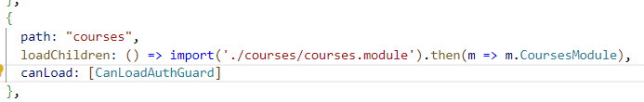

Angular Router in Depth – Other Topics
Angular Router Preloading Strategy
So by default, the angular preloading strategy will only load each module if needed.
We could modify this and create our own custom preloading strategy that would use different criteria for preloading or not different modules.
To do so we can change the configuration of our forRoot method:
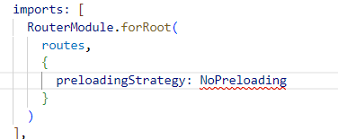
This is the default preloadingStrategy.
We can preload all lazy modules by using:
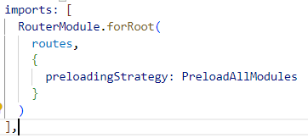
However all the preload strategies won’t work with module protected by canLoad Guards.
Angular Custom Preloading Strategy
So we want to be able to configure each module and decide if it should be preloaded or not, to do so we are going to be using here the data property of our route.
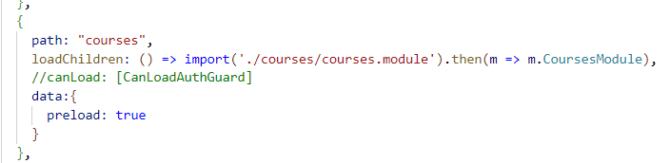
In order to implement our PreloadStrategy we implement the PreloadingStrategy interface in thw following way

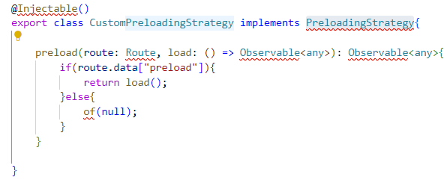
We are going to access the data property of the route object and from there we are going to check if the preload flag is set to true or not.
If the preload flag is set to true, then we are going to load the lazy loaded module associated with this route.
We can do so by calling load and by returning the resulting observable here as the output of preload.
On the other hand, if the module is not configured to be preloaded, then in that case we still need to return here an observable, but we want to return for example, the value null in order to indicate that no module should be preloaded.
So we are going to create here a new observable using the rxjs of factory function in order to create a new observable.
This observable is going to emit only the value null and then it's going to complete.
So now we are ready tu use our class in the AppRoutingModule:
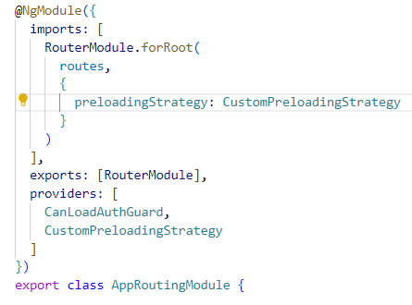
Angular Router Query Parameters
Now imagine that in the URL we would like to add at the end of the URL, a standard Http URL query parameter containing, for example, a temporary coupon code for a promotion that we would like to apply to this particular course.
So from here we already know how the parameter map works.
This contains all the path parameters such as, for example, “angular-router-course”, which uniquely identifies a given course.
But we also noticed here a second property which is called query parameter map, this is going to contain all query parameters currently present on the URL.
Notice that besides the query parameters being available here in the router snapshot which contains the state of the currently activated route, the first time that the component gets activated.
We can also get updates to these parameters if they change over time by accessing here the route query parameters observable.
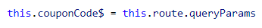
So this observable is going to emit as values all the query parameters emitted over time if we remain on the same instance of the course component while navigating from one route to the other.
In order to pass queryParams to the url from the template we can use:

Configuring routing behaviour with RouterLinkActiveOptions
So with the use of routerLinkActive options, we are now configuring the behavior of router link active in order to add the CSS class to this element only if there is an exact match between the current route on the browser URL and the value of the router link directive.
Angular Router Module Extra Options
So whenever we add the router module to an application, we need to start by adding it to the root module of the application using forRoot method, we are going to pass in here our rooting configuration.
Now after passing the routes in configuration, we can also pass a configuration object.
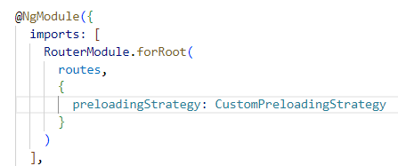
-There are many other configurations, for example, we can use the enableTracing option and set it to true in order to set the router module in debug mode.
This is going to log a lot of information to the console upon each root navigation and it's going to allow us to troubleshoot in case that something is going wrong with the router.
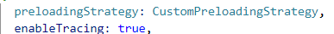
-Now, in general, it should be possible for you to be able to configure your back end server in production in order to always serve the index.html page independently of the content of the URL.
But if by some reason it's just not practical or possible for you to do that, then there is an alternative. Instead of using here full path segments, we can also configure the angular router in order to use URL fragments using here the hash character.
So this is the typical HTML syntax for adding HTML bookmarks to a given page.
To do so we can set hash to true:
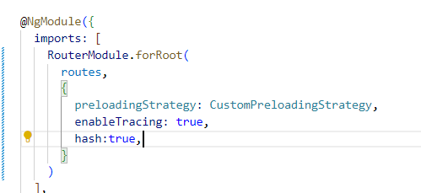
-Now what we want to do is to ensure that the angular router will always scroll to the top of the page after the router transition is completed.
That is not the case by default, so we can improve on that behavior by using the following parameter scrollPositionRestoration.
When we go forward, we scroll to the top of the page, when we go backwards, we restore th e scrolling position.
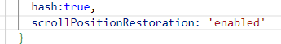

-Now in the lessonsDetailResolver we needed those two param from the url:
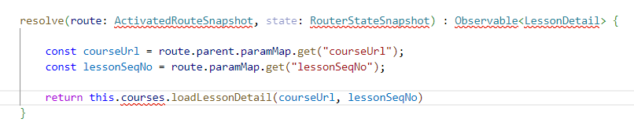
The first one is from a parent navigation component.
In order to avoid having to know to which route the parameter belongs to, we can instead access always the same top level parameter map and get any route parameter that might belong to the current route or to any of its parent routes:
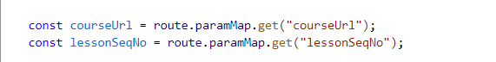
We could use paramsInheritanceStrategy:
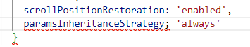
-For certain components, which are components that have empty paths, such as, for example,in our courses routing module, we have here the home component that is linked to an empty path for these components linked to empty paths.
Sometimes when we are trying to navigate in the template of the component using the router link directive to the current component, we notice that if we would use this syntax:

that we would expect to trigger a navigation to the current component would not work and we would be forced in order to navigate to the same component that we are on to navigate to the parent component like this:
which is, as you can see, very confusing and we would like to have to avoid to do this in our application. We can use relativeLinkResolution:
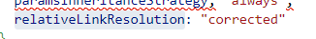
-Another usefull parameter is going to take in a function that is going to get triggered whenever there is a problem parsing the URL.
So if our URL has some strange character that is not well parsed by the browser, then this error handler is going to get triggered.
What we would like to do here is to redirect the user to the page not found in our application.
Most of this parameters are bugfixing from previous versions and is recommended to use them like this everytime we configure a new routerModule:
